Unilever (Hellmann’s) – Chicago, Illinois

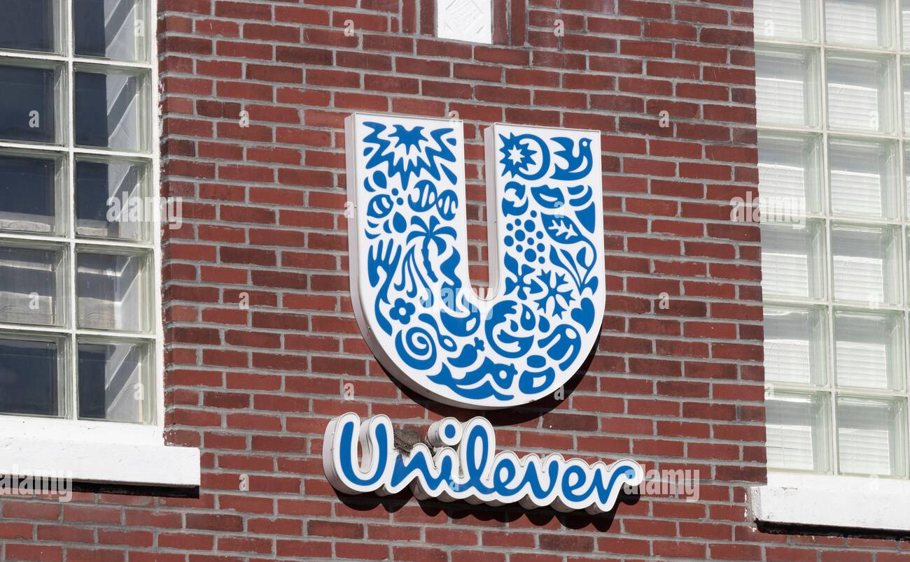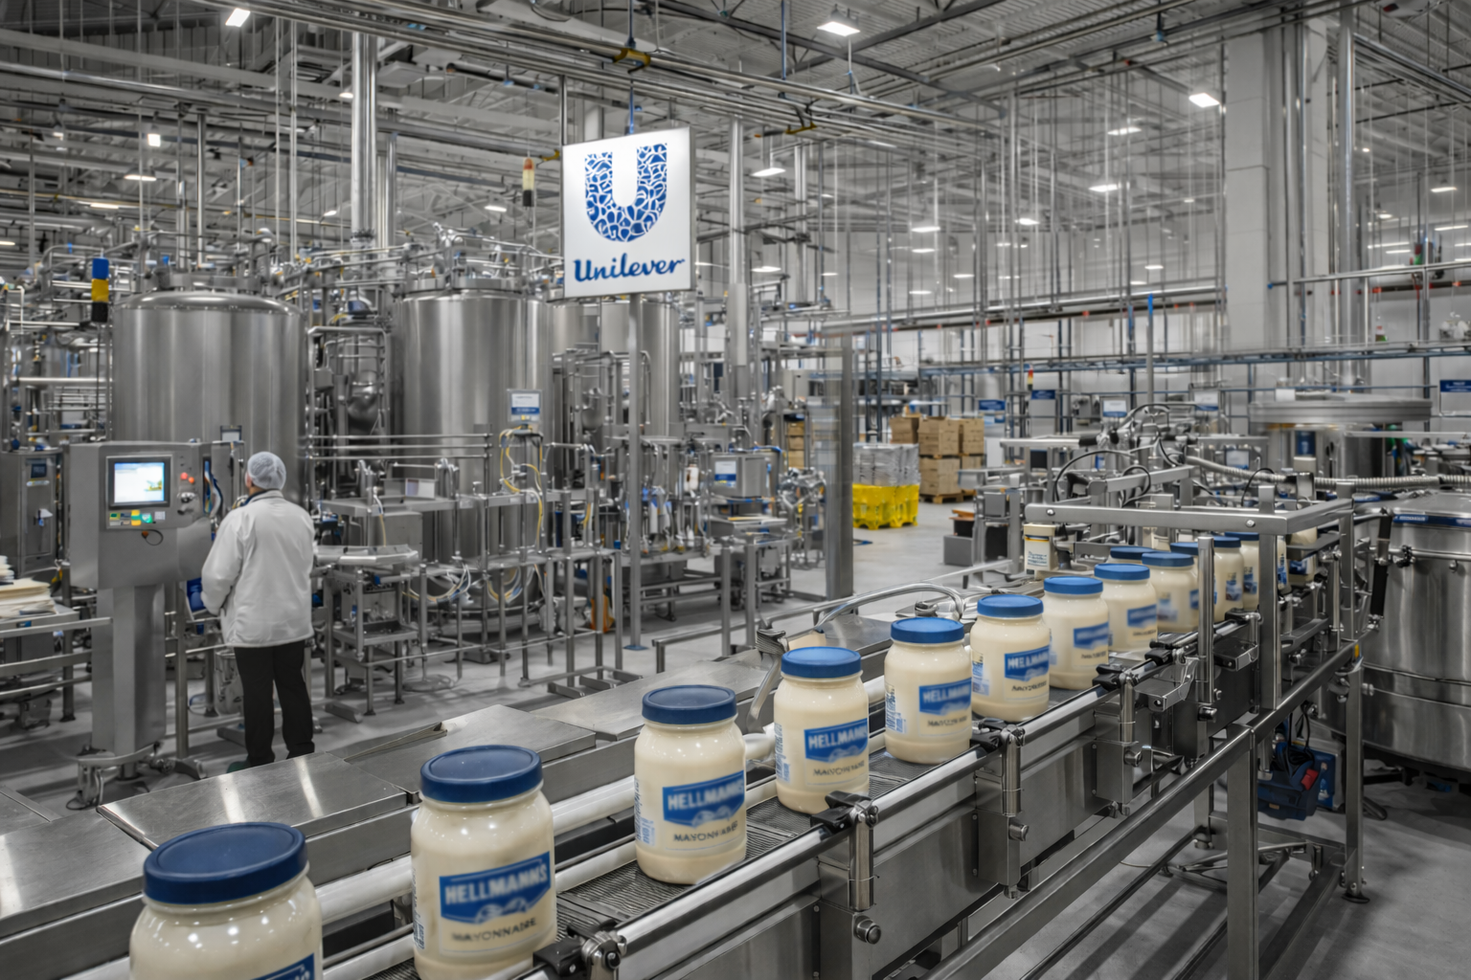

Challenge:
Unilever sought to reduce potable water consumption and improve site-level sustainability by capturing and reusing rainwater runoff at the facility. The solution needed to:
- Treat highly variable stormwater quality
- Operate reliably in an industrial environment
- Produce water suitable for on-site wash-down and utility use
- Integrate without major civil reconstruction

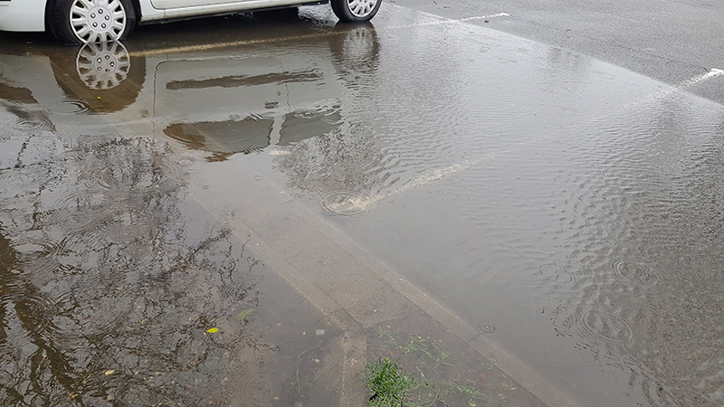
Storm water from facility was intercepted from roof and
parking lot catchments and diverted for treatment.

Solution:
Enereau designed and supplied a pressurized ultrafiltration (UF) membrane treatment system to treat captured stormwater runoff collected from the roof and parking lot drainage systems.
Key elements included:
- Pretreatment for solids and debris associated with urban runoff
- Pressurized UF membranes to provide a physical barrier to suspended solids, bacteria, and turbidity
- Automated backwash and cleaning sequences for reliable operation
- Integration with on-site reuse infrastructure for non-potable applications

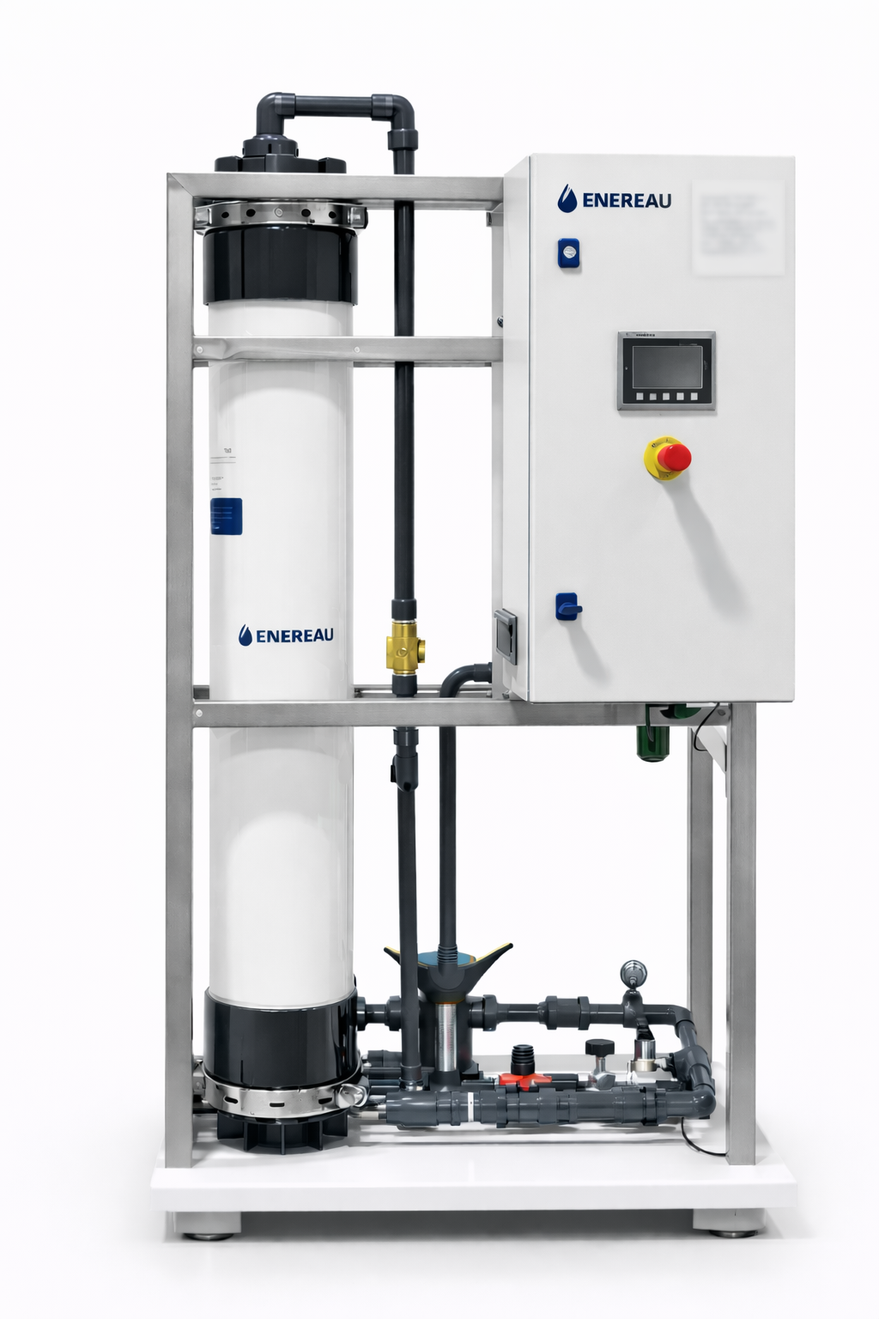
Automated ultrafiltration unit treated the storm water to
remove solids and bacteria to make it suitable for reuse.

Results
- Reliable production of high-quality reuse water for wash water applications
- Reduced potable water demand at the facility
- Improved stormwater management and reduced discharge volumes
- Supported corporate sustainability and ESG objectives

